Geometry: Unit 4, Lesson 7
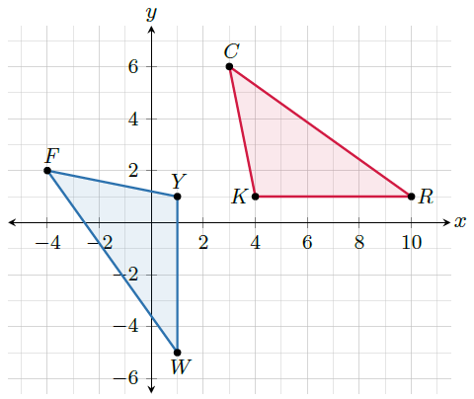
- Two congruent triangles are shown on the coordinate grid. The sequence of transformations that map triangle $YWF$ to triangle $KRC$ is given. What vertex does vertex $F$ map to?
$$(x, y)→(-y, -x)$$
$$(x, y)→(x+5, y+2)$$

C
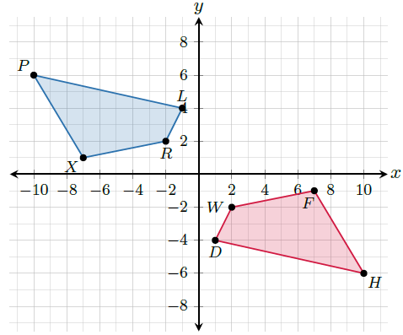

- Two congruent quadrilaterals are shown on the coordinate grid. Complete the congruence statement:
$$DWFH≅______$$

$$LRXP$$
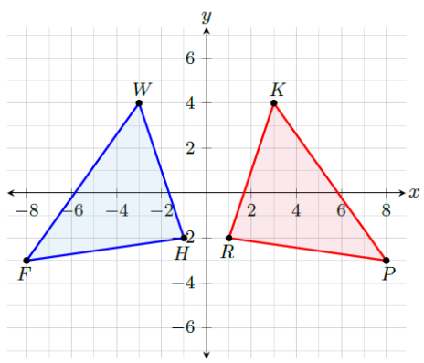
- Two congruent triangles are shown on the coordinate grid. What is a transformation that will map $FWH$ to $PKR$?

Reflection over the $y$-axis

